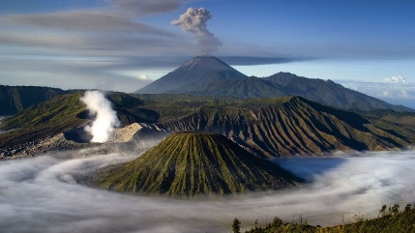

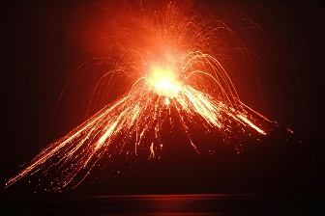
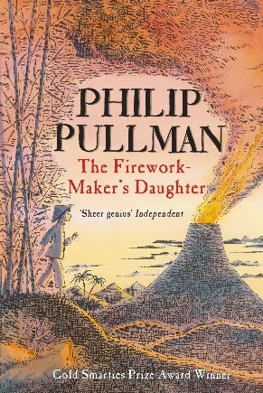

English

- Write a report about volcanoes
- Write a fact file all about mountains and volcanoes
- Write a leaflet about the volcanoes and mountains around the world
- Create a new story with the characters from our book

Make a 3D volcano structure
Make a firework, explosion picture
Create art with items you can find in nature
Sketch a picture of Mount Merapi and the enchanted lake from our book
Have a go at something you find difficult to improve your resilience
Practice your handwriting at home, can you show pride?
Make a poster about how we can protect the environment.
Create an idea for a new charity
- PLANTS!
- Make a poster about what plants need
- Make a veg patch at home
- Grow a plant and measure how much it grows every day
- Explore the outdoors what plants can you find?
Practice your times tables.
Can you get a high score on timetables rock stars?
Practice your 3, 4, 8 and 6 times tables.

Art & DT

Summer Term
Explosions

Science

PSHE

Maths

Homework Menu

