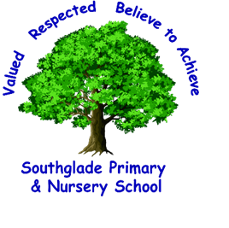
Southglade Primary and Nursery School
Beckhampton Road
Bestwood
Nottingham
NG5 5NE
Telephone: 0115 9155763
E-mail: admin@southglade.nottingham.sch.uk
Headteacher: Mrs A Thomas (B.Ed. Hons)

Dear Parent / Carer,
Cadburys World Trip – Monday 27th February 2023
We are excited to announce we are going on a trip! On Monday 27th February, Year 3 will be visiting the Cadburys World in Birmingham to learn more about our ‘Chocolate’ topic.
We will be leaving school at 8:45am and returning for 3:30pm. Children must wear their school uniform for this visit.
Our trip will consist of enriching opportunities that support the learning of our Design Technology curriculum. We will be learning all about the history of Cadburys, how chocolate is made and having a tour of the factory.
Children will need to bring a packed lunch for the day. If they are eligible for Free School Meals, school will provide them with a packed lunch. Please ensure too that your child has their own water bottle for the trip.

This will be our main trip in year 3, this year. We are asking for voluntary contributions of £15 for this trip to be paid via Parent Pay. We need as many contributions as possible to make this trip possible. We will be setting up a payment schedule on Parent Pay to pay in 3 instalments of £5 to cover the cost.
Please return the permission slip below to your child’s class teacher by Friday 16th December. If you have any further questions please ask.
Many thanks,
Miss Finnie, Miss Storer, Mrs Gormley and Mrs Adams (Year 3 Team)

_____________________________________________________________________________________
Year 3 Cadburys World Trip
I give permission for _________________________________ to attend the trip
Class ______________
Please tick the lunch option for your child below
Packed lunch from home School grab bag

Please tick if you have made a contribution via parent pay

