
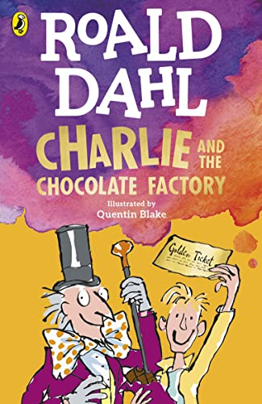



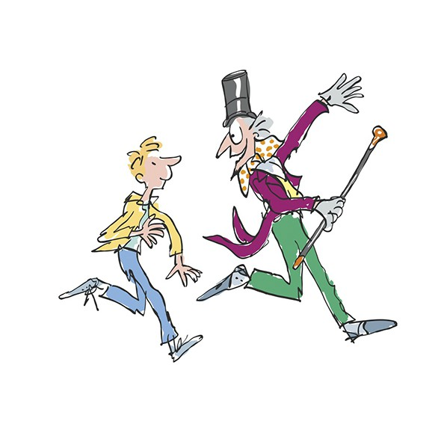
English

- Diary entry from Charlie the day he found his Golden Ticket
- Write a fact file all about Andy Warhol
- Create a new story with Charlie and the other children from our book

What does RESILIENCE mean to you?
Draw a storyboard showing how you show resilience at home.
Safer Internet Day:
Create a poster explaining how you stay safe online?

Make a golden ticket, just like the one in the book.
Make an Andy Warhol pop art picture inspired by your favourite object or food.
Create a 3D model of a chocolate factory or land of sweets and treats.

Practice your times tables.
Can you get a high score on timetables rock stars?
Practice your 3, 4, 8 and 6 times tables.

Art & DT

- MAGNETS!
- What magnetic items can you locate in your house?
- Design a magnetic game to play and make.
- Find out some magnet facts and how they work.
Spring Term
Imagination

Science

PSHE

Maths

Homework Menu

